**Multi-Node Docker Swarm Cluster for High Availability**

Step 1: Initialize Docker Swarm, Check the cluster

Step 2: Create a Docker Compose File

**Docker_compose.yml file**

Step 3: Deploy the Application on Swarm

Check service status

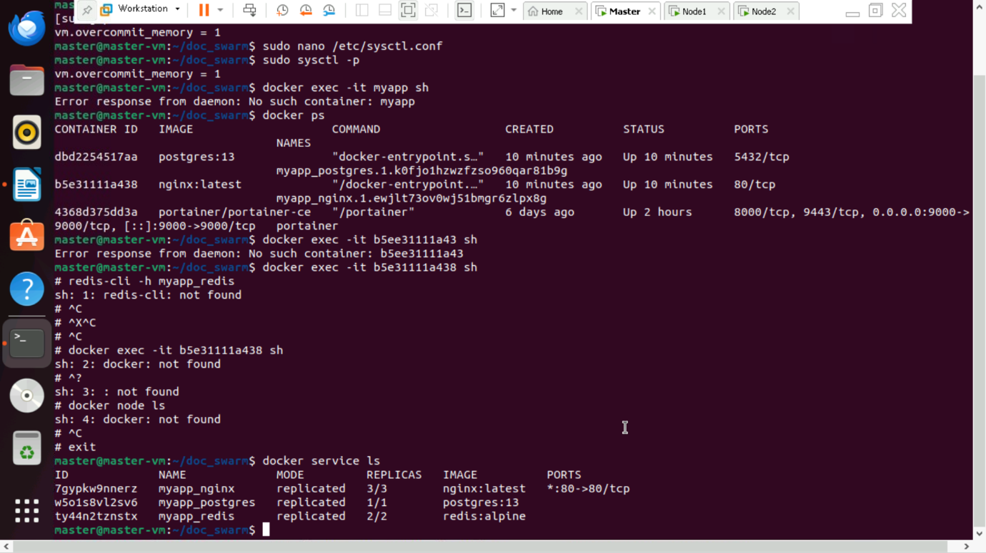

Copy the join token and add worker node-1

Copy the join token and add worker node-2

Pulled the postgres

